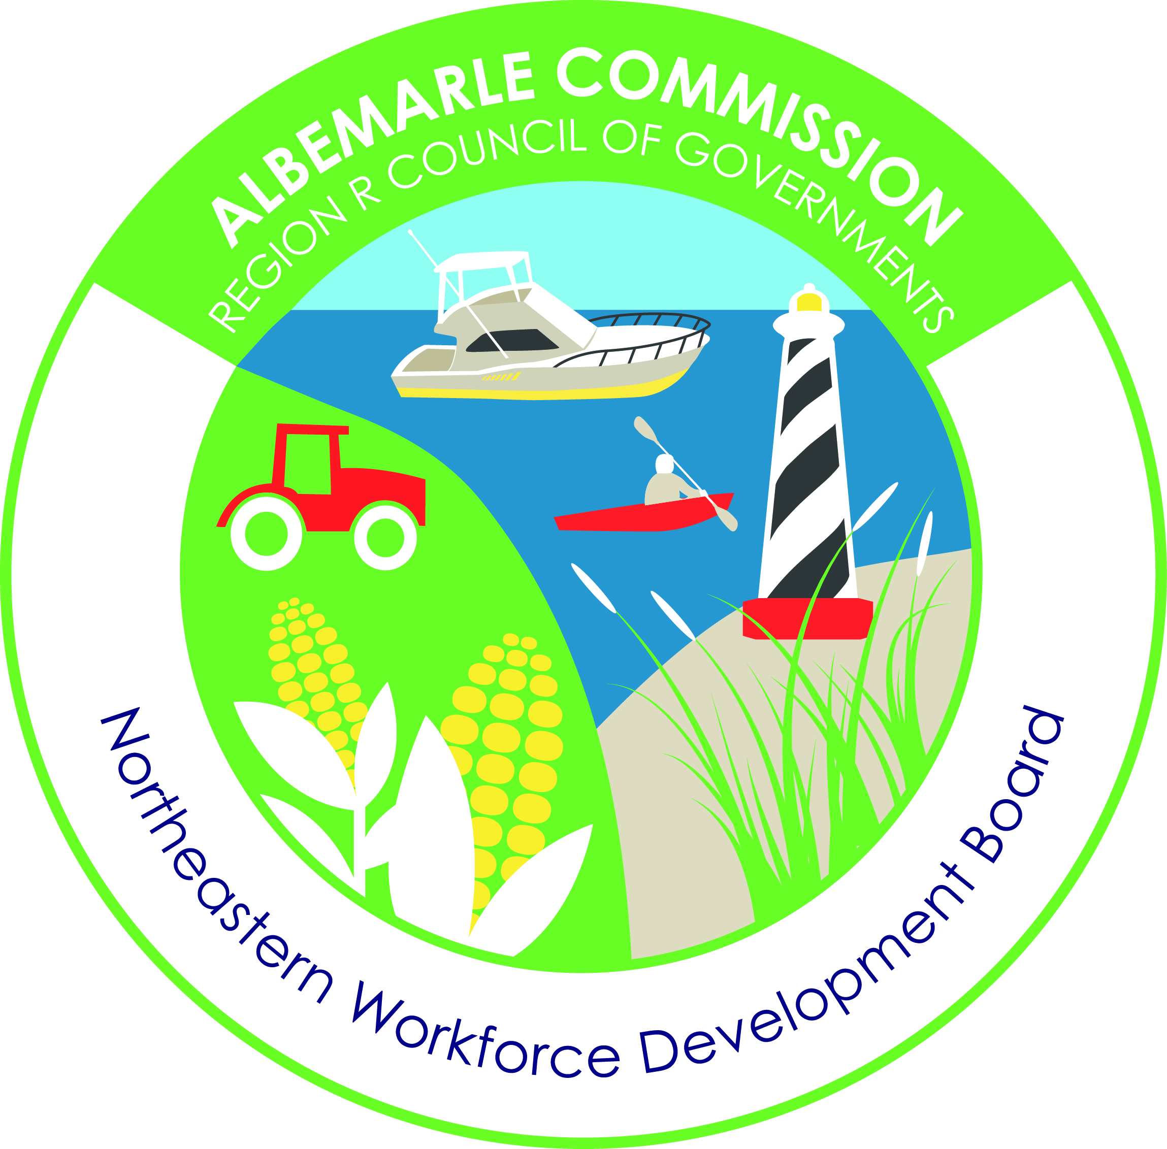
David Whitmer, director
dwhitmer@accog.org

ZACH BRAY, CHAIR
zach.bray@aemc.coop

Serving Camden, Chowan, Currituck, Dare, Gates, Hyde, Pasquotank, Perquimans, Tyrrell and Washington Counties

Board Member Application
Date: ______________________________________________________________
Name: _____________________________________________________________
County: _______________________
Address: ___________________________________________________________
Business Affiliation: Industry__________________Occupation________________
Currently Employed__________ Retired_________________
Contact Information:
Phone#_____________________Email:________________Other:_____________
Best way to contact you? ___________________
Why do you want to be a board member of the Northeastern Workforce Development Board? ______________________________________________________________________________
______________________________________________________________________________
____________________________________________________________________________________________________________________________________________________________
______________________________________________________________________________
____________________________________________________________________________________________________________________________________________________________
For Internal Use Only:
______________________________________________________________________________
____________________________________________________________________________________________________________________________________________________________

Please email application to cgossage@accog.org or mail to address below attn: Cindy Gossage

