NWDB Leadership Committee Meeting Minutes May 5, 2021

Present: Sean Lavin (Chair), Tameka Gibbs, Janet Russ (Vice-Chair) Kimberly Gregory, Emily Nicholson (staff), Annette Barnes (staff), Lora Aples (staff), Cindy Gossage (staff), Amber Morse (staff), Rachel Clipston (staff)
Absent With Notice: JD Williamson, Larry Lombardi
Absent Without Notice: None

- Welcome and Approval of Minutes: Chairman Lavin called the meeting to order and welcomed Dr. Kimberly Gregory as the new NextGen Committee Chair. Tameka Gibbs made a motion to approve the minutes of the April 2021 meeting. The motion was seconded by Sean Lavin and passed unanimously.

- Updates: Director Whitmer reported that the career centers are all open to the public without appointment and staff are not doing staggered schedules. The only location that is not open is the CDC at COA and that will open in August. Next Director Whitmer told the committee that things were going very well with the #worklocal initiative and we recently held presentations in Hyde and Tyrrell counties. The One-Stop operator monitoring is underway. It is an extensive process and will take some time to complete. Director Whitmer then informed the committee that he was able to get $75K in youth funds from other boards who are not able to spend their youth money. He believes we will be able to get an additional $50K. Director Whitmer next reported that NWDB staff housed at the Albemarle Commission building will be moving to a building next door. Staff are excited about this move. Director Whitmer and Assistant Director Nicholson will be conducting orientations for the new board members. Lastly Director Whitmer informed the committee that two board members have indicated that they would need to resign soon due to busy schedules – Teri Gallop and Diane White.

- Committee Chair Check-in:

Tameka Gibbs, reporting on behalf of the Career Center Committee, stated that the committee will be meeting later in the afternoon. She was glad that the Career Centers are completely open to the public.

Amber Morse, reporting on behalf of the BROC, stated the business services team has been very busy helping businesses with their recruitment needs. She also stated that the LMI project with NC LEAD is still on-going.

Director Whitmer, reporting on behalf of the finance committee stated that the committee is scheduled to meet next week.

Dr Gregory, reporting on behalf of the NextGen Committee, stated that our NextGen committee is scheduled to meet next week.

Chairman Lavin reported that he was excited to have ECSU represented on the board as he believes

this will help us continue to engage with the university.

- NWDB Board May Board Meeting: After discussion, the committee agreed to include the following on the May NWDB meeting agenda (along with normal agenda items).

One-Stop Operator vote; PY 21 Adult/DW and Youth Services vote; Sylvan contract extension vote

- A motion was made by Tameka Gibbs to adjourn. The motion was seconded by Vice-Chair Russ and passed unanimously.

Minutes prepared by Dave Whitmer.

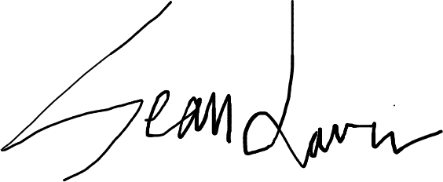
Approved by: Date: 06 / 25 / 2021

